WHONET – INFECT AMR Data Export



WHO Collaborating Centre for Surveillance of Antimicrobial Resistance
Boston, March 2026
Table of Contents
1. Background 2
2. About this document 2
3. WHONET Configuration 2
4. How to export data in the INFECT AMR format with WHONET 3

Background
From the INFECT AMR website:
“INFECT AMR delivers a clear, color-coded view of antimicrobial resistance data, helping healthcare professionals make precise, data-driven treatment decisions with ease. Its advanced filtering allows users to target the most relevant resistance insights tailored to specific patient cases.”
For more information about INFECT AMR, please visit their website: https://infect-amr.com/

About this document
This document describes how to use WHONET to generate INFECT AMR-compatible export files from WHONET data.
If you do not yet have WHONET data files, you may visit our website’s training page to see documentation regarding the options available, such as importing an electronic data feed with BacLink, or manual data entry with WHONET. https://whonet.org/training.html

WHONET Configuration
A typical WHONET configuration associated with your data files will already include the data fields necessary to produce an INFECT AMR export because the key fields for INFECT AMR align very well with the core WHONET data fields. Because of this, there is typically no need to adjust your WHONET configuration to produce this export.
The complete list of WHONET data fields for this export is listed below. To be accepted by the INFECT AMR platform, your data must contain the required fields. If an optional field is missing, then the system will automatically ignore this field.
For the resulting export to be accepted by the INFECT AMR platform, the required fields must be present in your configuration and populated in your WHONET data files. You can adjust the data fields for your laboratory using the “Modify laboratory” feature available from the main WHONET menu.
Required fields:
Identification number (PATIENT_ID), Organism (ORGANISM), Specimen collection date (SPEC_DATE)

Optional fields:
Age (AGE), Specimen type (SPEC_TYPE and SPEC_CODE), Location type (WARD_TYPE), Department (DEPARTMENT), Institution (INSTITUT), Patient sex (SEX), Region (variable list, please see the note below).

Note on the optional “Region” data field:
Most of the data fields listed above are standardized WHONET fields, using known code sets that are managed for the user. However, for the “Region” data field to work properly with the INFECT AMR platform, the values for “Region” in your existing WHONET data should match those that you have configured in the INFECT AMR platform.
Because users might have this information stored in a field other than the WHONET “Region” (REGION), this data field is optionally selected from a list during the data export.
You may use the standard WHONET “code list” feature to create options to choose from during manual data entry.

How to export data in the INFECT AMR format with WHONET
- From the main system menu in WHONET, choose “File”, “Open laboratory”.
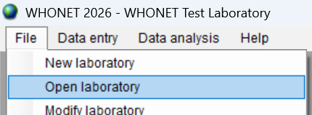
- Open the configuration associated with your data using the form which appears.
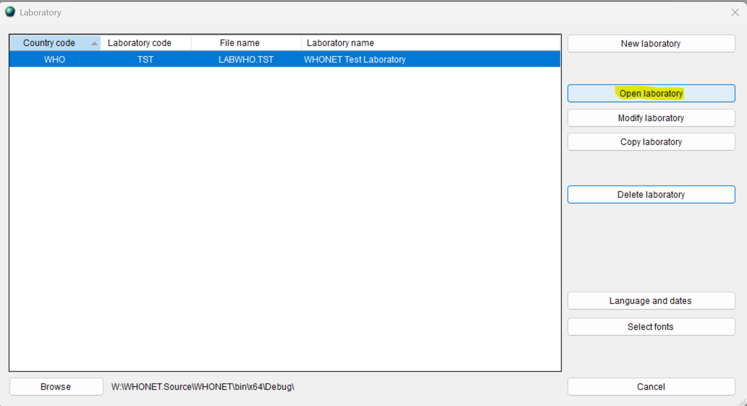
- From the main system menu, choose “Data entry”, “Combine, export, or encrypt data files”.
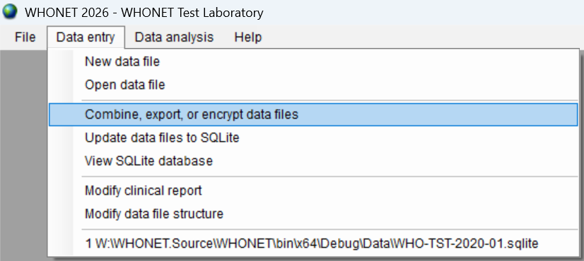
- Choose “INFECT AMR” from the list of data exports as shown below.
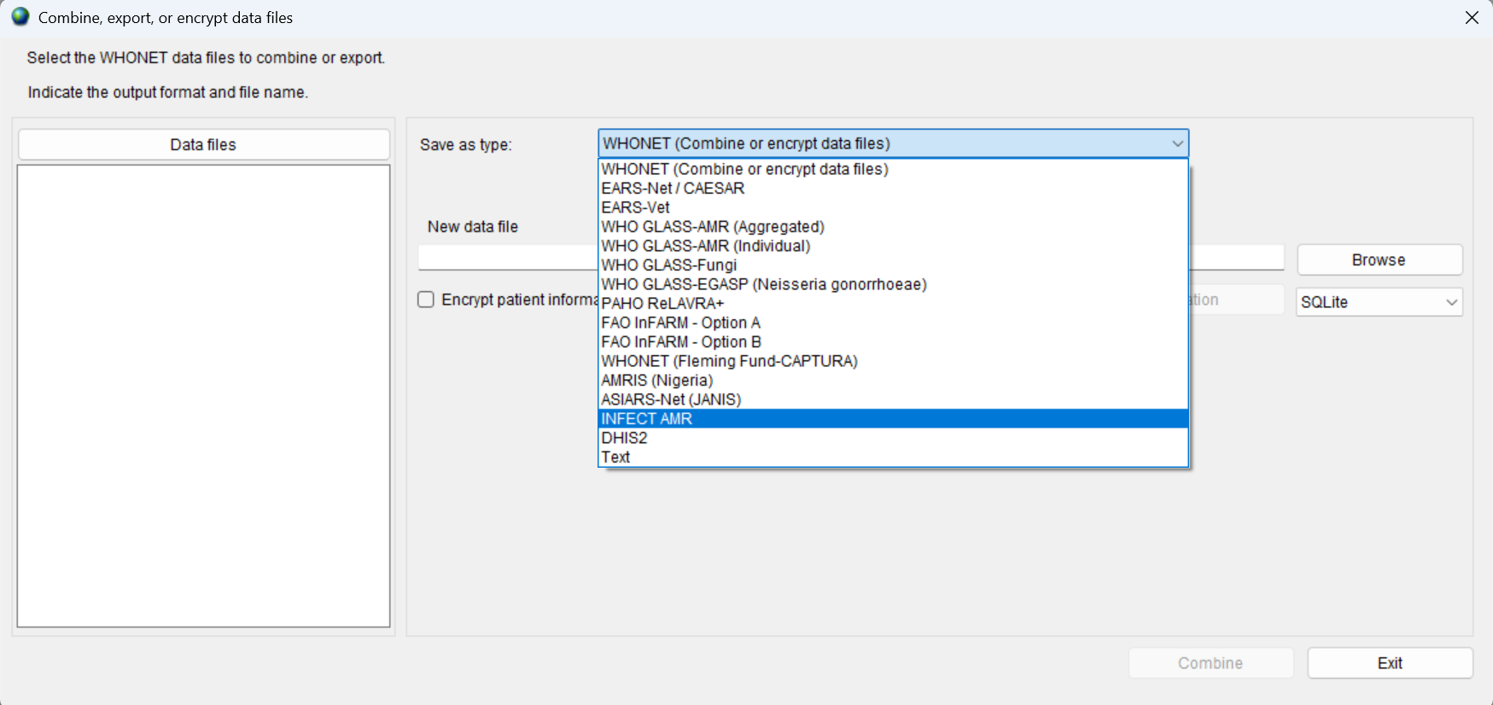
- Choose an output file name using the “Browse” button to the right of the “New data file” entry area.
- Use the “Data files” button on the left to select WHONET data files to be included with the data export to INFECT AMR.
- If you have the “Region” data values, you may choose the corresponding data field on the list, as shown below, or choose “None” if you do not have this information in your data feed.
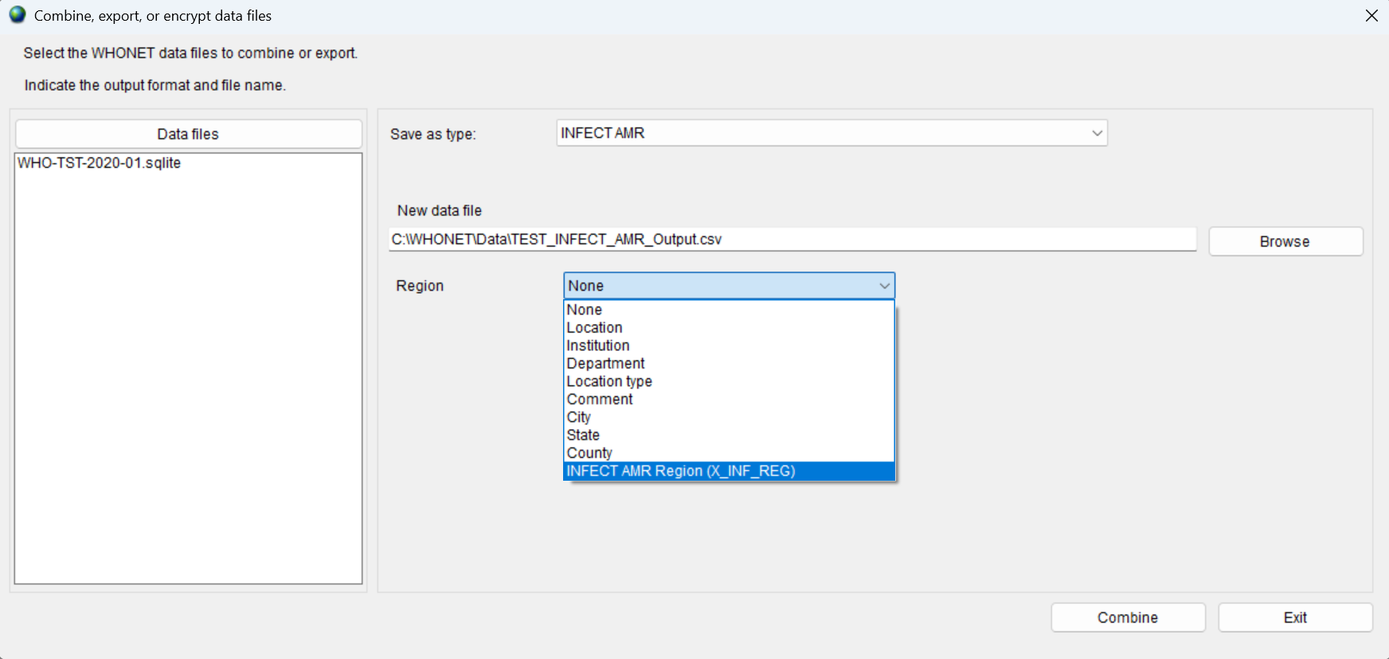
- Press the “Combine” button near the bottom of the screen.
- After the export is completed, you should be presented with the following message.
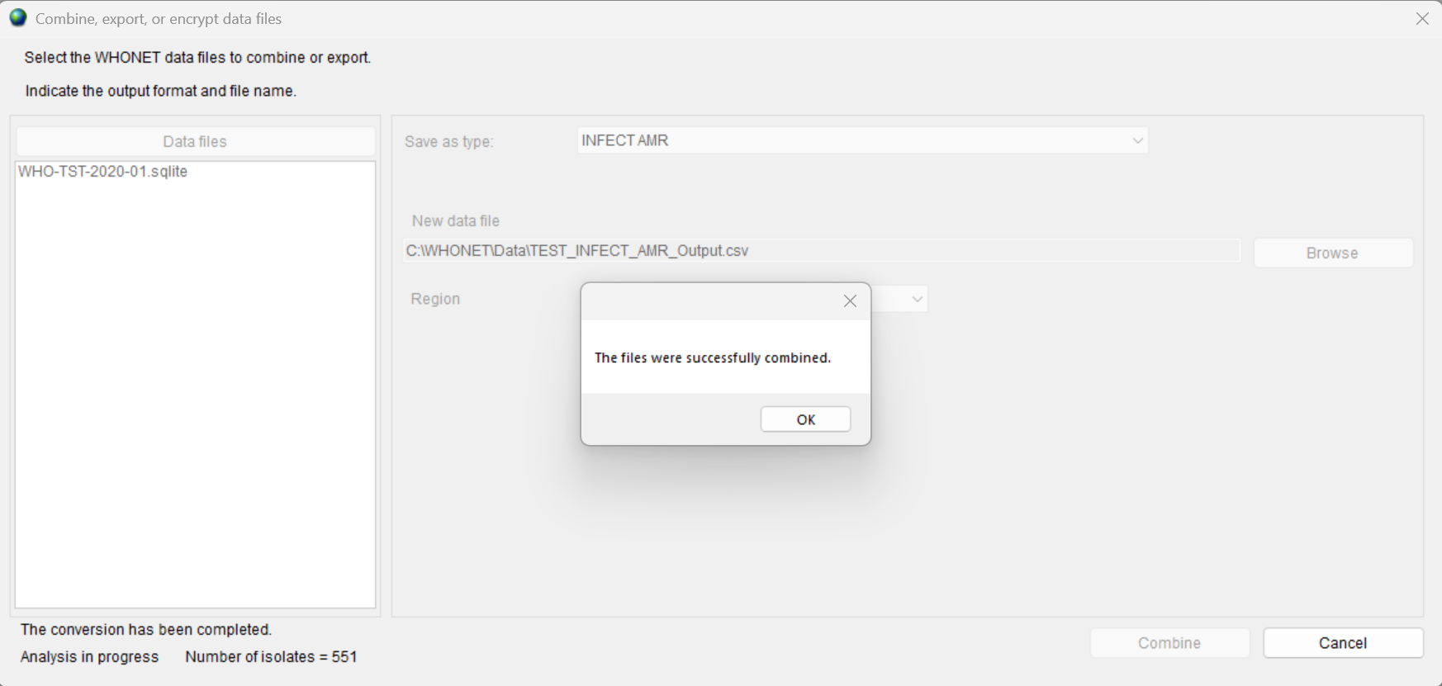
- You may now proceed to upload the output file to the INFECT AMR platform. Please seek guidance from the INFECT AMR website for more information about this process. https://infect-amr.com/
- If you have additional questions about or issues with the WHONET-INFECT AMR export process, please do not hesitate to write to help@whonet.org with your questions.

