WHONET – InFARM Data Export



WHO Collaborating Centre for Surveillance of Antimicrobial Resistance

Boston, July 2024

Table of Contents

Background 2

About this document 2

How to create a WHONET configuration for the InFARM protocol 2

Manual data entry 4

How to export data in the InFARM Model A and B format 5

## Background

InFARM stands for the “International FAO Antimicrobial Resistance Monitoring System”. More information can be found at the following URL:  
<https://www.fao.org/antimicrobial-resistance/resources/database/infarm/en/>

The InFARM protocol is subdivided into two categories: Model A (isolate-level data) and Model B (aggregate statistics). Countries can choose between submitting more granular data with Model A or aggregate statistics with Model B. Countries make these determinations using the InFARM web portal, and then use the corresponding settings in WHONET to generate the data files for upload to the portal.

## About this document

This document describes how to use WHONET for generating the InFARM Model A & B exports, as well as optional manual data entry when data feeds (processed via BacLink) are not available.

## How to create a WHONET configuration for the InFARM protocol

If you do not have data to process with BacLink, you can use WHONET for manual data entry instead. You can use the same WHONET-InFARM configuration to open InFARM data files that have been created with BacLink or through manual data entry.

1. Open WHONET and choose “Cancel” on the laboratory configuration screen.

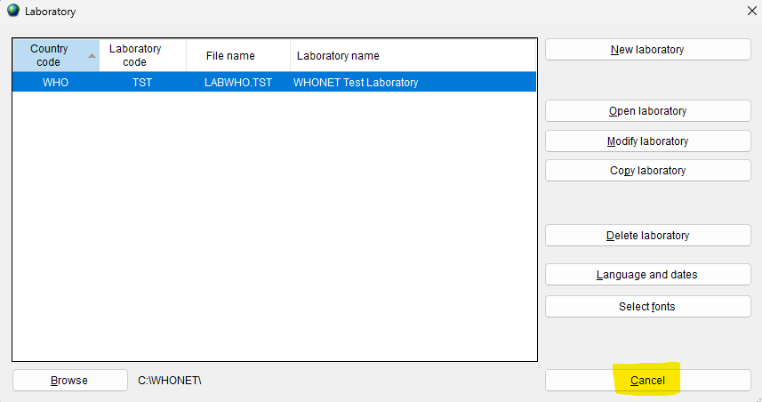

1. Press “File” on the main menu, then select “FAO - InFARM” and finally “New laboratory” as shown below.

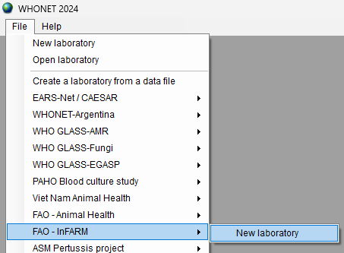

1. Fill in the details for your country, laboratory name and code.
   1. Be sure to select “Human, Animal, Food, Environment” so that the relevant data fields will be added to your configuration.
   2. Press “OK”.

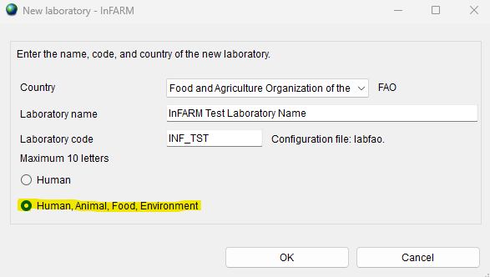

1. The next question will ask you whether you predominantly test using CLSI or EUCAST guidelines. Please choose the most appropriate answer here. Additional antibiotics can be added (from either guideline) after your default configuration has been generated with this process.
2. After confirming your guidelines above, your new configuration will be generated. You will be presented with the option of viewing the details on the next screen. If you need to make modifications, press “Yes”. If not, you may continue to the main WHONET screen by pressing “No”.

## Manual data entry

When an LIS or instrument data feed is not available, you may use the configuration generated above to enter data using WHONET’s interface. If there is a data feed available with the laboratory results relevant for InFARM, it is highly recommended that you use BacLink to process that data into a WHONET-readable file rather than using the manual data entry procedure described below.

For more information on BacLink as it relates to InFARM, please consult this document or seek further assistance from the InFARM and WHONET teams. <https://whonet.org/Docs/BacLink_InFARM_Data_Import.docx>

If you are unable to obtain a data feed that can be processed with BacLink, please follow the manual data entry procedure outlined below.

1. Open the InFARM configuration by pressing “File”, “Open laboratory” and choosing the InFARM configuration you have created previously.
2. From the main menu, choose “Data entry”, “New data file”.
3. A data entry screen should appear with questions and code lists corresponding to the InFARM protocol. You may use this screen to enter your data and view the existing isolates in the data file.
   1. Please ensure that the “Origin” selection at the top of the screen is set to “Animal” or “Food” or “Environmental” as appropriate.

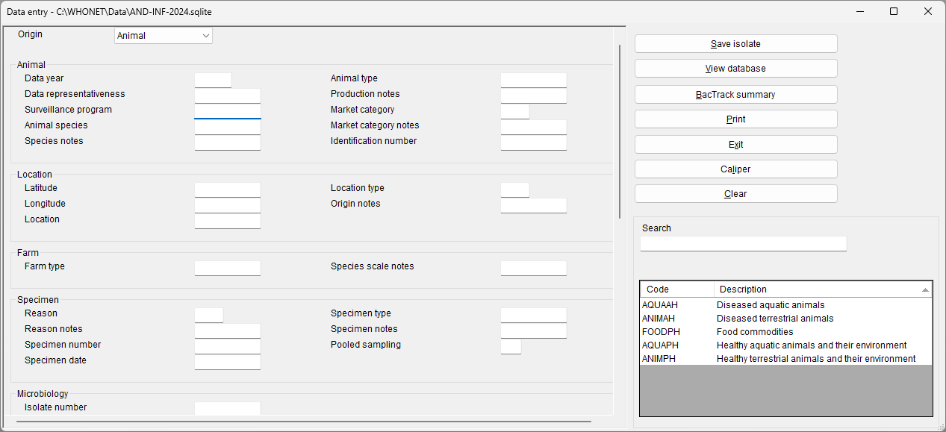

1. For further information on general WHONET data entry, please see the documents found on your computer by pressing “Help”, “Documentation” from the main WHONET menu, or online at the following URL.
   1. <https://whonet.org/WebDocs/WHONET_9.Data_entry_Isolate_entry.pdf>

## How to export data in the InFARM Model A and B format

There is only a single method for data export regardless of whether you have manually entered data or used BacLink to process your data feed.

1. Using “File”, “Open laboratory”, select the InFARM configuration generated with one of the methods described above.
2. From the main WHONET menu, press “Data entry”, “Combine, export, or encrypt data files”

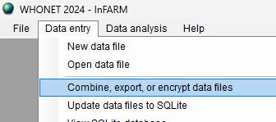

1. Press the “Data files” button and select one or more data files to include in the export.
2. From the “Save as type” menu, choose either “FAO InFARM – Model A” or “FAO InFARM – Model B”.

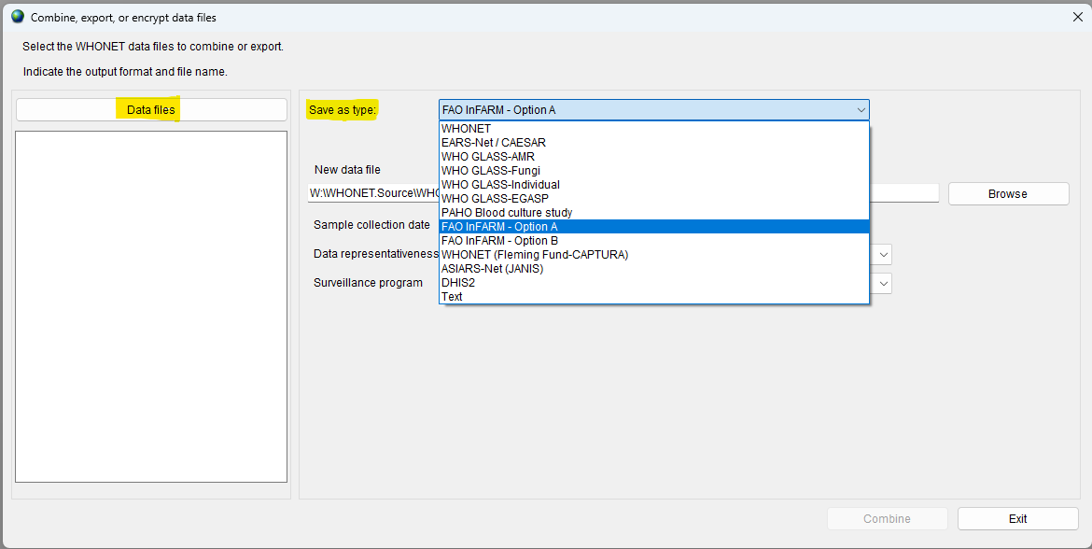

1. When you activate one of these exports, another set of options will appear below as shown. The responses should match the configurations you have previously set up on the InFARM web portal. Note that the “New data file” name will change automatically to match the InFARM protocol’s rules whenever one of the options changes.
2. Note the checkboxes to highlighted in yellow below. When these are checked, the system will filter your selected data files according to the associated option to the left of the checkbox. If you uncheck them, the system will not apply the filter (allowing more isolates into the eventual output). You should only uncheck a checkbox if you are sure that all the isolates in your selected data files are for the corresponding combination of data year, data representativeness and surveillance program that you have selected.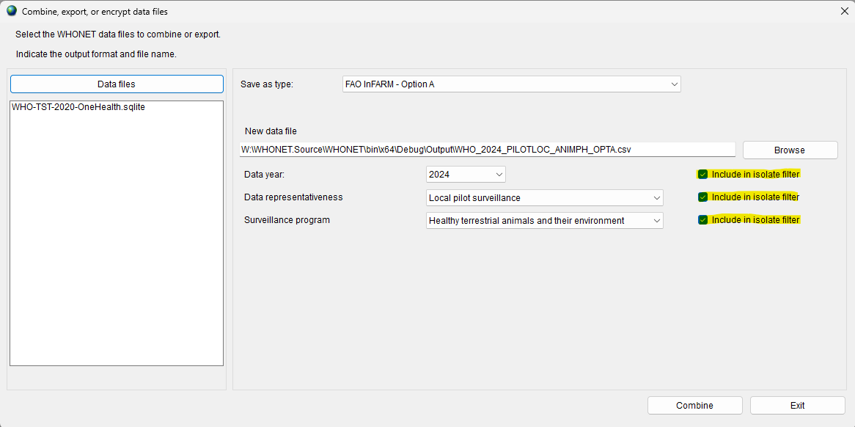
3. Press “Combine”. You should receive a message indicating that the conversion completed successfully, which will also allow you to view the file contents.

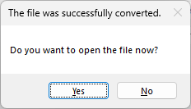

1. Answering “Yes” to the prompt above will open screen which allows you to view and filter the InFARM output file you have just created.
   1. Close the viewer when you have finished.
2. The output file will be in the “C:\WHONET\Output\” folder on your computer by default and will be named according to the value provided in the “New data file” text box on the “Combine, export, or encrypt data files” form.
   1. This file is ready to be uploaded to the FAO InFARM platform.
   2. If you need to generate additional exports for other surveillance programs, etc., you may repeat steps 4 – 8 selecting the relevant options each time.