WHONET – InFARM Data Validation Utility



WHO Collaborating Centre for Surveillance of Antimicrobial Resistance
Boston, December 2025
Table of Contents
1. Background 2
2. About this document 2
3. Accessing the InFARM data file utility from the WHONET main menu 3
4. Validating an existing InFARM data file 4
4.1 Data suppression 4
5. Generating or validating antibiotic results 5
5.1 A note about the “Breakpoints” section 5
5.2 Generating antibiotic interpretations 6
5.3 Validate existing interpretations 6

Background
InFARM stands for the “International FAO Antimicrobial Resistance Monitoring System”. More information can be found at the following URL:
https://www.fao.org/antimicrobial-resistance/resources/database/infarm/en/
The InFARM protocol is subdivided into two categories: Model A (isolate-level data) and Model B (aggregate statistics). Countries can choose between submitting more granular data with Model A or aggregate statistics with Model B. Countries make these determinations using the InFARM web portal and then use the corresponding settings in WHONET to generate the data files for upload to the portal.

About this document
This document describes a utility contained within the WHONET software which provides validation and interpretation features relevant for InFARM data files. This utility is designed to operate on the InFARM file itself, not standard WHONET data files. The utility accepts Option A or B data files to generate validation reports. It can also generate or validate antimicrobial interpretations and substitute the values into a copy of the original InFARM file (Option A only). Finally, the utility offers the ability to suppress records which violate one or more of the issues described by the validation report.
You do not need a WHONET configuration file to use this InFARM-specific utility. For certain users, it will be appropriate that they only use this feature of WHONET and ignore the rest of the WHONET software.
If you have WHONET data files and need to prepare InFARM data files, please use the standard WHONET features described in the following document: https://whonet.org/WebDocs/WHONET_InFARM_Data_Export.pdf
The utility described below does not create InFARM data files given WHONET data. Instead, it is used to validate or provide antimicrobial interpretations for existing InFARM files, regardless of their source.

Accessing the InFARM data file utility from the WHONET main menu
To use the utility, please first install the WHONET software by downloading it from our webpage: https://whonet.org/index.html
- Once installed, launch the WHONET software by clicking the icon on your desktop or the Windows Start menu.
- You will be presented with a screen requesting that you select a laboratory configuration file. As mentioned in the above section, this is not relevant when utilizing the InFARM data utility, so you may press “Cancel” on the form shown below.
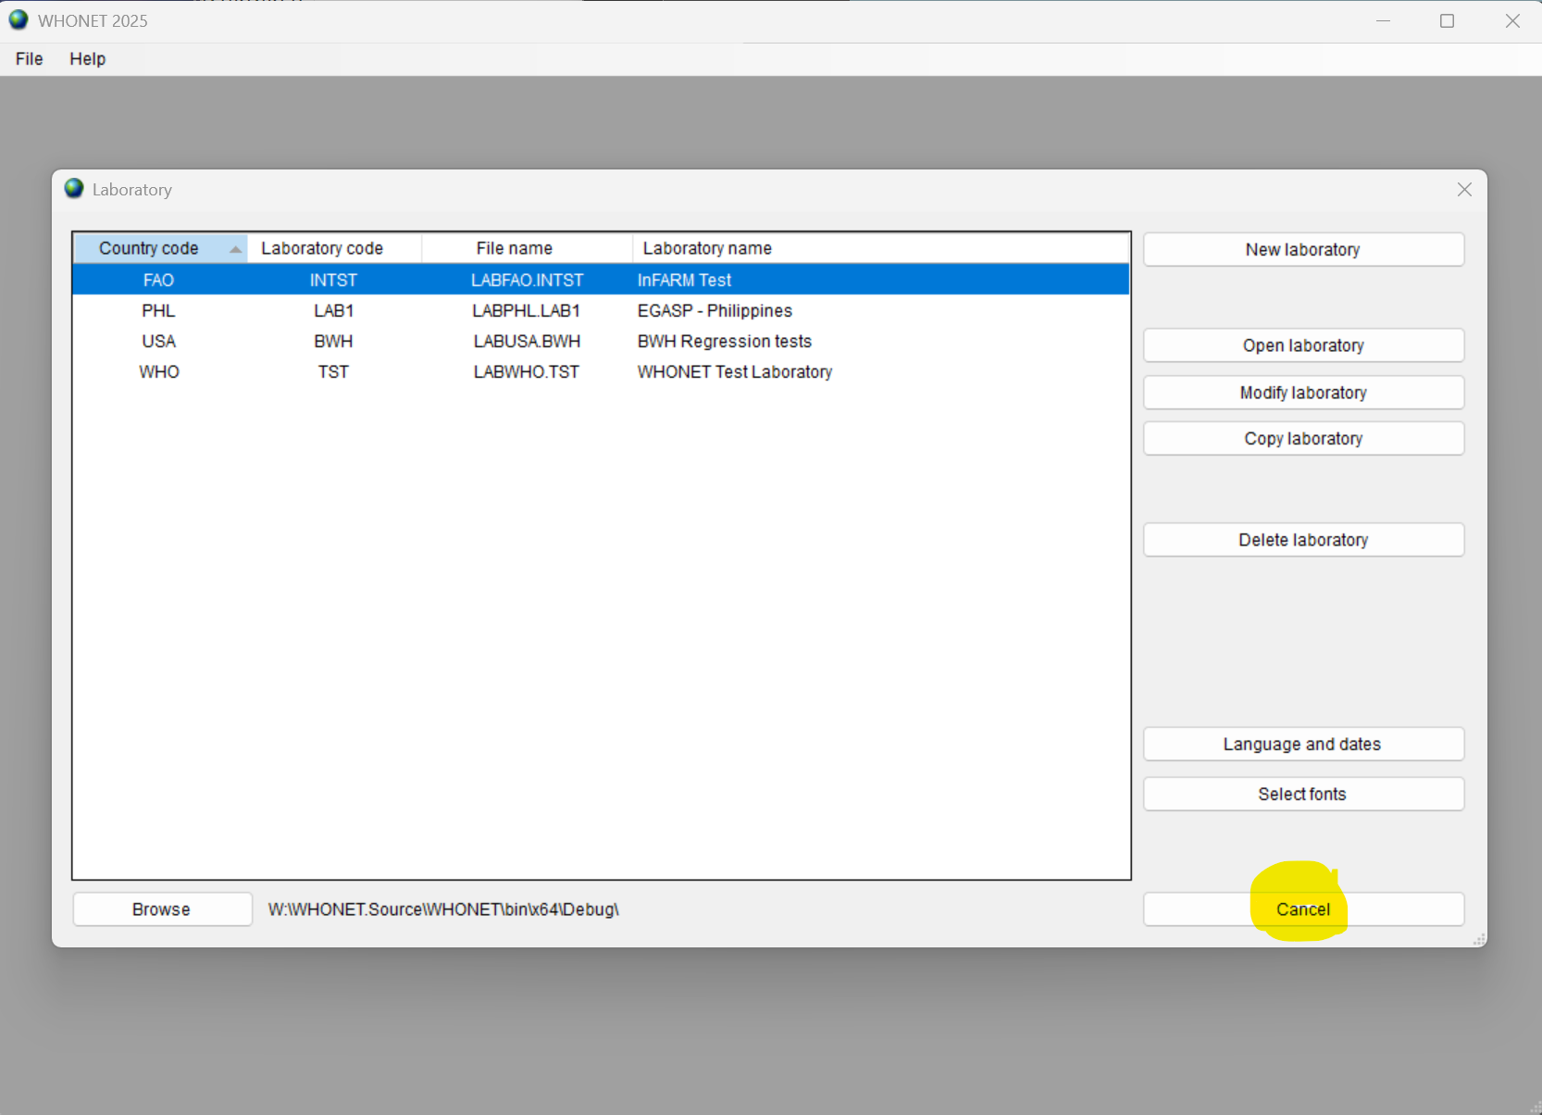
- From the main WHONET menu, press “File” and expand the “FAO InFARM (Global)” menu shown below.
- Select the “Data file utility” at the bottom of this submenu.
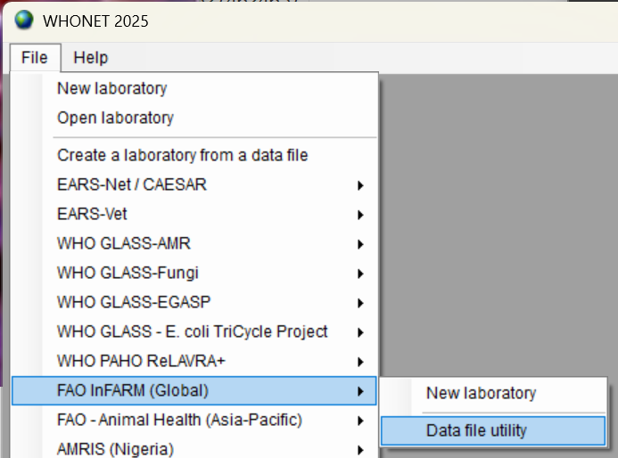

Validating an existing InFARM data file
You should now see the utility form shown below.
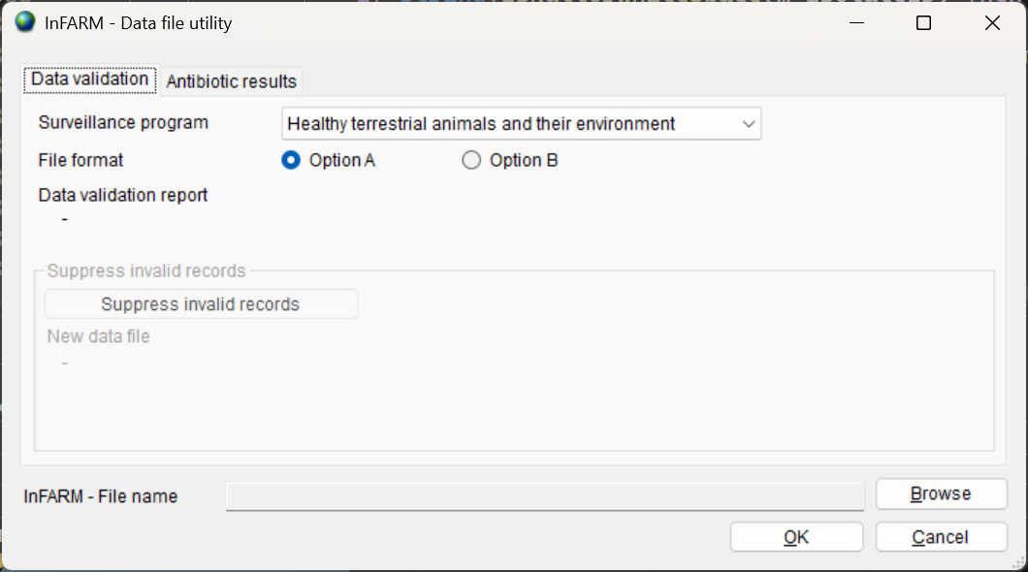
Note that there are two available categories of functions, which are accessed by clicking the corresponding tab near the top of the form (“Data validation” or “Antibiotic results”).
The “Data validation” tab will allow you to analyze an existing InFARM Option A or B data file to generate the same data validation report users receive when they create InFARM data exports from their local WHONET data files. The report’s contents are described in the document found here: https://whonet.org/WebDocs/WHONET_InFARM_Data_Validation_Report.pdf
To generate the validation report, select the surveillance program associated with your InFARM data file, as well as indicating whether it is an Option A or B data file. Once you’ve selected the appropriate options, press the “Browse” button near the lower right of the form, and select the corresponding InFARM data file you wish to analyze.
Press the “OK” button near the bottom of the form to generate the validation report. When the analysis is completed, you should receive a message asking if you wish to open the report with Microsoft Excel. The Excel report will automatically be saved to the same folder on your computer where the InFARM data file is located. The location and file name will also be displayed on the form.

Data suppression
Once you’ve successfully generated the feedback report and reviewed its contents, the section of the screen shown above for “Suppress invalid records” will become active. This feature will remove all the offending records mentioned in the feedback report. Your original InFARM data file will not be altered. Instead, a new file will be created with the remaining subset of the original records which passed validation. The new file will be in the same folder as your original InFARM data file, but the file name will now end with “_VALID.csv”.
It is very important to take great care when using this feature to avoid inadvertently suppressing important data, which should have been remedied another way. This feature is intended to assist users with cleaning unwanted data from their files, but you must make this determination by carefully reviewing the feedback report. For example, if data which should be reported to InFARM are systematically miscoded, then this problem should be addressed directly rather than suppressed from the output.
To suppress all records which have an issue according to the feedback report, simply press the “Suppress invalid records” button shown above. After the suppression process is completed, you will be presented with an option to view the new data file through the WHONET user interface.
You can optionally utilize a 3rd party tool for comparing text files if you would like a detailed, line-by-line comparison between the original InFARM data file and the new “cleaned” output. Some examples of such tools are:
https://winmerge.org/downloads/?lang=en
https://sourceforge.net/projects/kdiff3/files/

Generating or validating antibiotic results
Features relating to antibiotic interpretation generation and validation reside on the second tab labeled “Antibiotic results”. Press this tab to access these features as shown below.
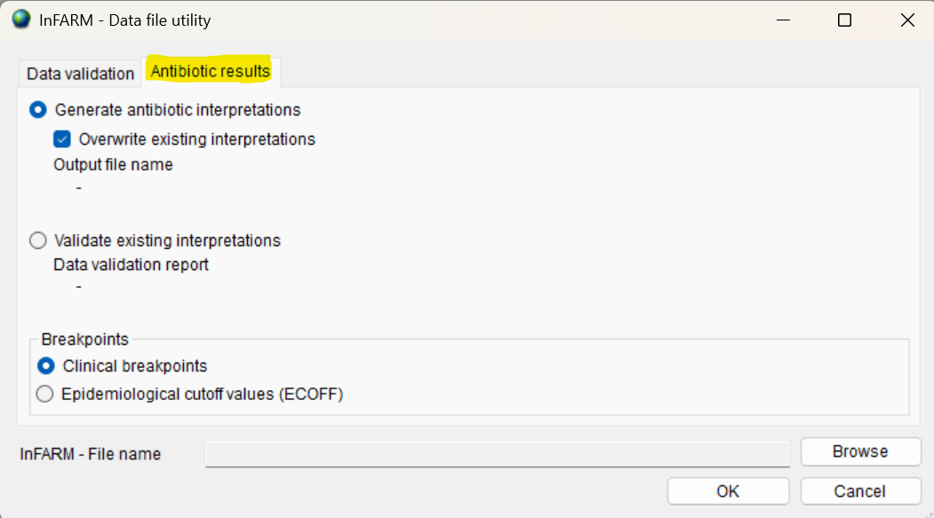
Using the corresponding radio buttons, you may elect to either “Generate antibiotic interpretations” or “Validate existing interpretations”.

5.1 A note about the “Breakpoints” section
The options contained in the “Breakpoints” section near the bottom are applicable for both the “Generate antibiotic interpretations” and “Validate existing interpretations” features. These options instruct the utility to use either clinical breakpoints or ECOFF values for generating or validating the interpretations.

5.2 Generating antibiotic interpretations
Using this feature, you can populate your InFARM Option A data files with antibiotic interpretations. InFARM Option B data files do not contain individual antimicrobial interpretations, so they are not relevant for this feature of the utility.
It is important to note that your original InFARM data file will not be modified. This system creates a copy of your original data in the same folder on your computer and appends “_INT” to the file name. For example, if your InFARM Option A data file is named “InFARM_Option_A_2025.csv”, the resulting copy will be named “InFARM_Option_A_2025_INT.csv”. The output data file name will also be displayed below the “Output file name” label shown below the “Overwrite existing interpretations” checkbox once you execute the analysis.
The system will analyze your data file and insert the interpretation value corresponding to each test measurement into the appropriate row and column of data. By default, the “Overwrite existing interpretations” checkbox is enabled. This checkbox will allow you to override any existing interpretations that are already present in the file. For example, if an E. coli isolate has a test measurement for Ampicillin along with a potentially incorrect interpretation, this checkbox will allow you to overwrite that interpretation with the WHONET-generated value.
If the “Overwrite existing interpretations” checkbox is disabled, the original interpretations will be left unchanged in the output file, but any completely missing interpretations will be provided by the system.
Once you have decided whether to overwrite any existing interpretations in the output, use the “Browse” button near the lower right of the form to choose an Option A data file to analyze. Press the “OK” button to create the copied output file containing the newly generated antibiotic interpretations.
After the process is completed, you will be presented with an option to view the output file in the WHONET user interface.

5.3 Validate existing interpretations
This feature will scan an existing Option A data file to determine whether the interpretations in the file match those that WHONET would have generated. It will prepare an Excel report which contains a list of any discrepancies. The system will ask you if you would like to open the report once it is completed. The file name and location for this report will also be displayed below the “Data validation report” label.
The image below shows a sample from the antibiotic interpretation validation report (the data presented has been fabricated). The system displays the InFARM specimen number and isolate number to assist you with investigating issues you may discover. It also displays the offending antimicrobial column name, as well as the test result (measurement), local test interpretation (if any) and finally the expected interpretation value.
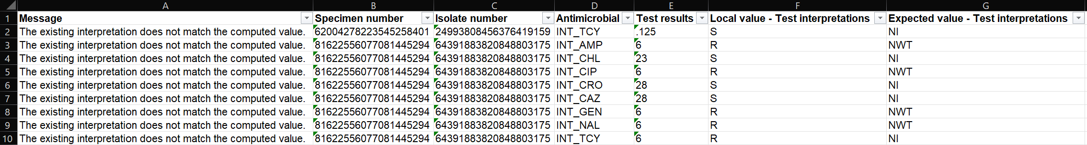
In the example above, the system analyzed an InFARM data file which contained interpretations derived from the clinical breakpoints, but the breakpoint option for “ECOFFs” was used for validation to demonstrate the mismatched values. In the rightmost column, you can see the interpretations associated with the ECOFFs.

