WHONET for EARS-Net Manual

John Stelling
Brigham and Women’s Hospital
WHO Collaborating Centre for Surveillance of Antimicrobial Resistance
Boston, Massachusetts
March 2026

CONTENTS

1. Introduction 3
2. Downloading and installing WHONET 6
3. Laboratory configuration 7
3.1 Creating a New Laboratory Configuration 7
3.2 Modifying Laboratory Configuration 10
3.3 General laboratory information 10
3.4 Antibiotics (Antibiotic Configuration) 11
3.5 Antibiotic Breakpoints 12
Special instructions for utilizing WHONET 2026 for submission of data utilizing 2025 breakpoints 13
3.6 Locations 14
3.7 Modifying Data Field Configuration for EARS-Net 14
3.8 Copy an existing laboratory configuration 15
4. WHONET Data entry for EARS-Net 17
4.1 General 17
4.2 Field specific comments: 19
4.3 View database 21
5. Exporting WHONET files to the EARS-Net exchange format 22
6. Upload the EARS-Net data file to the EARS-Net data platform - EpiPulse Cases. 25

Introduction
This manual is written for national EARS-Net data managers. It can also be used by data managers of laboratories that participate in EARS-Net. It describes how to use WHONET in handling data for EARS-Net. WHONET supports output of data to the EARS-Net exchange format. This is not a complete manual for WHONET, which can be downloaded from the WHONET home page at www.whonet.org.

The EARS-Net management team recommends:
- The use of WHONET, because:
- it is freeware, downloadable from the WHONET Home Page, www.whonet.org.
- it allows for quick and comprehensive data analysis,and may thus stimulate a laboratory to study its own data.
- WHONET supports the output to EARS-Net data exchange format.

Document revision history
Date | Comments
June 5, 2021 | Review of the 2015 manual based on WHONET 5.6.  Updated guidance on software installation  Updated screen grabs from WHONET 5.6 to WHONET 2017+
April 25, 2022 | Review conducted of the 2021 manual. There were no relevant protocol or software modifications.
April 6, 2023 | Review conducted of the 2022 manual. There were no relevant protocol or software modifications.
April 10, 2024 | Review conducted of the 2023 manual. There were modifications in the EARS-Net protocol, including additional antibiotics, but these do not impact the instructions for exporting data from WHONET to the EARS-Net data structure.  The WHONET screen for reviewing breakpoints has been modified. The concept of ‘General breakpoints’ has been removed. The relevant screen grab has been updated, and relevant modifications to the text have also been introduced.  The EARS-Net Data check/Feedback Report has been removed from WHONET. Consequently, this section has been deleted.
June 28, 2024 | A new ‘Save’ feature has been added to the EARS-Net export data validation report screen. This will be useful for saving the validation report findings for follow-up reviews and action by national data managers and/or contributing laboratory staff.
April 10, 2025 | In WHONET 2025, the export function for the creation of EARS-Net files has been updated to include the EpiPulse Cases data specifications required for data submission from 2025 on. It will not be possible to utilize WHONET 2024 or earlier versions to create WHONET files compatible with EpiPulse Cases.  A new section has been added to ‘3.5 Antibiotic breakpoints’ in this manual to provide guidance on upgrading to WHONET 2025, but utilizing EUCAST 2024 breakpoints to submit data collected in 2024. The section has the heading ‘Special instructions for utilizing WHONET 2025 for submission of data utilizing 2024 breakpoints’  One screen capture in this manual has been updated to remove “TESSy” from the user interface.
March 23, 2026 | The WHONET screen for management of breakpoints has been updated to distinguish between the “new” and “old” ways of managing interpretation breakpoints. The relevant screen capture and text in Section 3.5 have been updated.  Guidance for how to utilize WHONET 2026 to create EARS-Net files with EUCAST 2025 breakpoints has been simplified compared to the previous year’s text as it is no longer possible to use versions prior to WHONET 2025 to create EARS-Net files following the migration of the data submission platform from TESSy to EpiPulse Cases.  A new WHONET feature has been introduced in WHONET 2026 that facilitates the selection of the correct breakpoints when creating EARS-Net data files directly from the “Data export” screen. There is a new option called “Data year”. Select the year that corresponds to the year when the samples were collected. Further details are available in Section 5.

For comments and questions, you may contact:

John Stelling, MD, MPH
Co-Director, WHO Collaborating Centre for Surveillance of Antimicrobial Resistance
Brigham and Women’s Hospital
Microbiology laboratory
75 Francis Street
Boston, Massachusetts 02115
United States
E-mail: jstelling@whonet.org
Phone: +1 617 935 9407

Downloading and installing WHONET

The software is available from the WHONET Home Page at www.whonet.org. From this page, you have the option of downloading either the 32-bit or 64-bit version of WHONET. For most users, there should be no difference in performance between the two versions, but for those who encounter compatibility issues when saving to Excel, we would recommend downloading the WHONET that corresponds with the locally installed version of Excel (32-bit or 64-bit). You can find the version when you open Excel, choose ‘Account’ from the main side menu, and click on ‘About Excel’ as in the below screen from Excel 64-bit version.

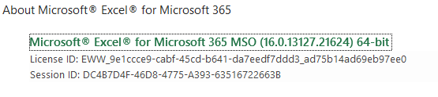

WHONET needs a computer running Microsoft Windows, versions 95 or later. After downloading the software, then double-click on the downloaded file, and follow the instructions on the screen (‘Run’, ‘OK’, etc.). If you receive a message about ‘insufficient administrative rights’ to install the software, then you will need to contact your facility’s system administrator to install the software for you or to give you the needed local administration rights.

The default location for the WHONET installation is C:\WHONET. You may change this as you wish. For example, if you would like to use WHONET on a network drive to permit shared use by multiple staff members, then you can install the software to a common drive, such as T:\WHONET. You will need to repeat this process on each of the computers from which you would like to use WHONET.

In case you already have older versions of WHONET on your PC, then install the updated WHONET to the same directory as the older version. This will overwrite all of the WHONET program files, but it will leave your own configuration, data, and user files untouched. In this way, you can continue using WHONET just as you did before the software update.

After installing the program you will find the WHONET and BacLink icons on your PC.

Laboratory configuration

3.1 Creating a New Laboratory Configuration

In WHONET, there are three principal ways to create a new laboratory configuration: 1. New laboratory; 2. Create a laboratory from a data file (especially useful for users of BacLink); and 3. ‘EARS-Net / CAESAR’, 'Create a new laboratory’. The purpose of this third option is to create a new laboratory configuration consistent with the EARS-Net reporting protocol. It is especially useful if you plan to enter results for the optional EARS-Net fields.

To use this third option for configuring an EARS-Net laboratory:

- Start WHONET, the below screen appears, hit ‘Cancel’

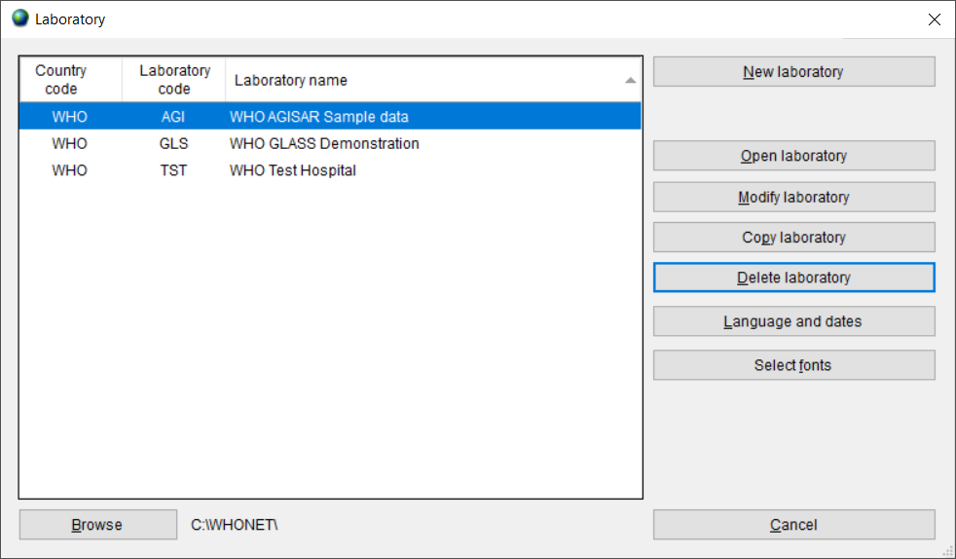

Then the main WHONET screen appears.

- Click ‘File’, ‘EARS-Net / CAESAR’ and ‘New laboratory’, as in the below screen.

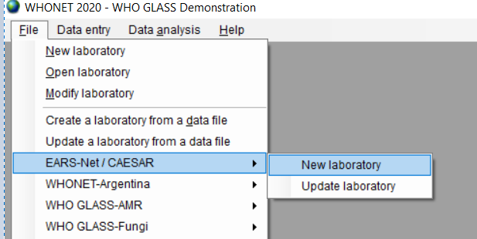

.

- Choose your country (‘World Health Organization’ in the below example) and enter a laboratory name (‘EARS-Net Demonstration Laboratory’) and a short laboratory code (EDL). In most EARS-Net countries, laboratories are identified by a numeric code, such as 008. Then click OK.

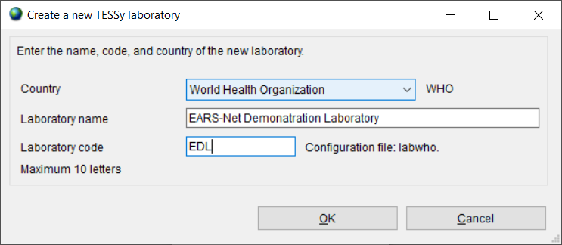

- Select ‘EUCAST’ from the list of guidelines provided.

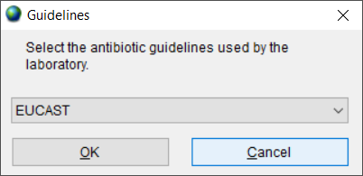

- Select the cefoxitin disk potency used for MRSA detection, which is typically 30 micrograms for EUCAST, and click ‘OK’. Or ‘Not tested’ if cefoxitin disk is not used.

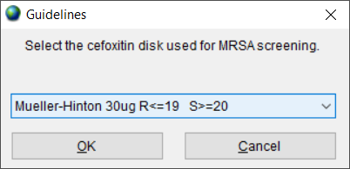

WHONET will create a new laboratory with the recommended set of EARS-Net antibiotics, data fields, and codes. You will then be prompted with the following screen.

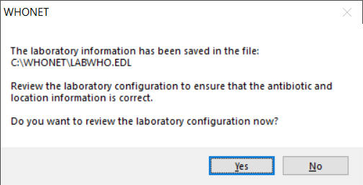

- If you want to review the configuration and make any additional modifications, select ‘Yes’. Otherwise, select ‘No’ to proceed directly with WHONET Data entry and analysis.

Before you start with data entry, we recommend that you review to check if it is necessary to make changes to the antibiotic interpretative breakpoints. For details how to make any additional changes we refer to the next section (3.2).

If you are responsible for working with multiple facilities, you may use the ‘Copy laboratory’ feature to clone this first EARS-Net laboratory to new ones, assigning a new name and code to each additional facility that you create. This is described in further detail in Section 3.8. You may also wish to create a ‘national’ laboratory configuration, for example ‘All laboratories’ which could be utilized for analysing and managing data from any of the contributing laboratories in the country.

Modifying Laboratory Configuration

You may want to create or modify a specific ‘laboratory configuration’ for each laboratory that participates in EARS-Net. The steps in making or modifying a configuration of a laboratory are:
giving or changing a name and code to the laboratory corresponding to the EARS-Net laboratory code; entering the antibiotic list and corresponding breakpoints; and modifying the list of WHONET data fields for EARS-Net.

If you have used the feature ‘EARS-Net / CAESAR’, ‘New laboratory’ feature, then the below steps are generally not required. But you may wish to remove antibiotics and data fields that you do not feel are needed, and you may wish to add additional antibiotics and data fields, even though they are not requested by EARS-Net.

General laboratory information

Step 1 Collect information on antibiotics, test methods and breakpoints specific for the participating laboratory.
Step 2 Start WHONET by double clicking on the WHONET icon. When you enter ‘New Laboratory’ the Laboratory Configuration screen appears.

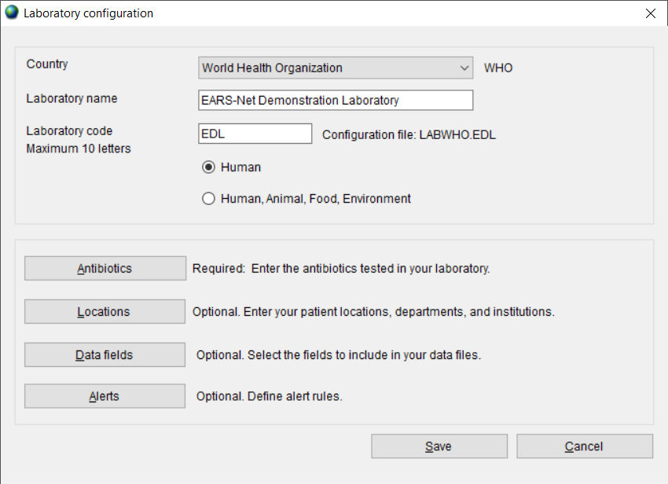

Step 3 Describe Laboratory (Required): Choose the country and enter the name of the laboratory. Enter the Laboratory code, use the corresponding three-characters of the code for the laboratory assigned by the national representative for EARS-Net.

Note: after entering this information WHONET will automatically create a corresponding laboratory configuration file name with the name labccc.xxx, where ccc = 3-letter ISO country code and xxx = 3 characters of the EARS-Net laboratory code. In the above example, the file name would be LABWHO.EDL.
Step 4 Antibiotic Configuration, Initial (Required): Click on ‘Antibiotics’ to configure the antibiotics. Enter the list of antibiotics that are being used by the laboratory and click ‘Close’ when finished to return to the main Laboratory Configuration screen. For details see 3.4 ‘Antibiotics (Antibiotic Configuration)’.

Antibiotics (Antibiotic Configuration)
To indicate which antibiotics, methods and breakpoints are being used in the participating laboratory you have to enter Antibiotic Configuration. Note: during data entry the software performs automatic interpretation based on the breakpoints entered in this configuration.

Instructions
Step 1 From the main ‘Laboratory Configuration’ screen, click on ‘Antibiotics’. You will see the below screen. The ‘WHONET Antibiotic List’ appears to the left, while the antibiotics that you select will appear to the right under ‘Local Antibiotic List’. The list on the right is already filled with EARS-Net antibiotics.

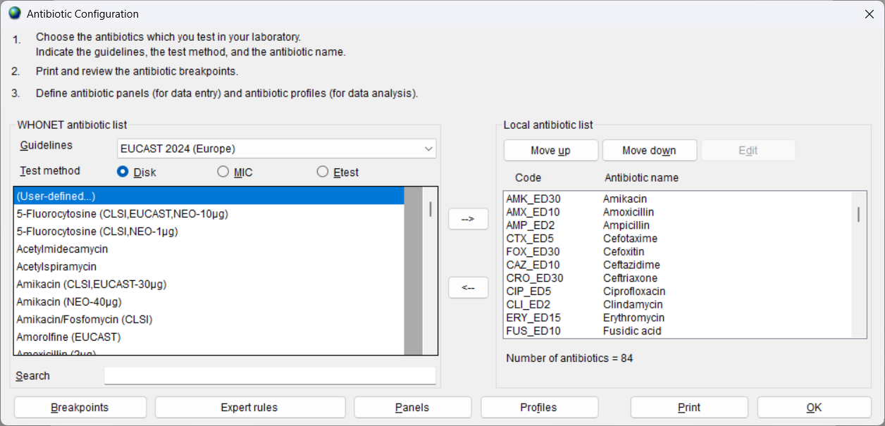

Step 2 For each combination of antibiotic, method, and testing guidelines:
- select the correct testing guidelines (EUCAST)
- AND click on the correct test method (disk diffusion, MIC, ETest®)
- AND select the correct antibiotic (and disk potency for disk diffusion testing)

You can select an antibiotic by double-clicking on it or, alternatively by clicking on it once and then clicking the right arrow button ‘-->’.

When you finish entering your antibiotics, review the list and make any needed corrections. To remove an antibiotic from the list, double-click on the antibiotic or single-click on the antibiotic and hit the left arrow button ‘<--’. You may change the sequence of the antibiotics with ‘Move Up’ and ‘Move Down’ buttons.

Note: Each antibiotic test is given a code (up to nine letters) consisting of: the three-letter antibiotic code, a one-letter code indicating the guideline reference (E=EUCAST), a one-letter code indicating the test method (D=disk diffusion, M=MIC, E=ETest® = Gradient diffusion for the EARS-Net export file), and a disk potency for drugs tested by disk diffusion. For MIC or ETest you only have to select the correct antibiotic and correct guideline – the disk potency indicated is not relevant. For example, the code GEN_ED10 represents: gentamicin, EUCAST, disk diffusion, 10 µg, while GEN_EM is: gentamicin, EUCAST, MIC.

Step 3 When you are satisfied with the list, you have the following options:
- ‘OK’ to return to the main ‘Laboratory Configuration’ screen. Note the information has to be saved by clicking on ‘‘Save’ in the main ‘Laboratory Configuration’ screen.
- ‘Panels’ and ‘Profiles’ are optional; to facilitate data entry, you may wish to use 'Panels' to indicate which antibiotics are tested for each kind of organism. For details refer to the WHONET manual.
- ‘Print’: obtain a printout of your antibiotics and their breakpoints. It is recommended that you print out your breakpoints for your review and reference before you start data entry.
- ‘Breakpoints’ to review, modify, and update the antibiotic breakpoints. See 3.5 below:

3.5 Antibiotic Breakpoints
WHONET will automatically load the most recent breakpoints for the antibiotics which you have indicated. Although not recommended for most users, it may happen that a laboratory uses other breakpoints than standard reference breakpoints, and for these situations you can edit the WHONET-provided standard breakpoints.

Instructions

Step 1 From the ‘Antibiotic Configuration’ screen, click on ‘Breakpoints...’. The following screen should appear.

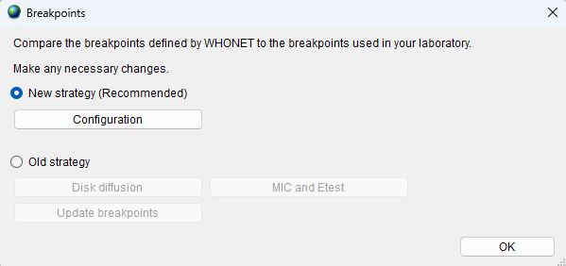

Step 2 You have the following options:
‘Disk diffusion’ and ‘MIC and Etest’: review and edit the list of species-specific disk diffusion or MIC breakpoints. For details, see Step 3.

‘Update breakpoints”: The WHONET antibiotic definition files are updated annually as new recommendations from the reference authorities become available, so we recommend that you update your WHONET at least annually. If you are using WHONET’s new strategy for the management of antibiotic breakpoints (available since 2020), then no further action is needed – WHONET will begin to use the new breakpoints immediately. On the other hand, if you are still using WHONET’s older strategy for breakpoint management, then you should click on “Update breakpoints” on the above “Breakpoints” screen once a year to keep your interpretations up to date.

‘Expert rules’: These are not required for EARS-Net data management. Refer to the WHONET manual for further details.

‘OK’: When you finish reviewing and/or modifying the antibiotic breakpoints, selecting ‘OK’ will return you to the ‘Antibiotic Configuration’ screen.

Step 3
Editing Species-Specific Antibiotic Breakpoints. You will see a screen similar to the one below. For EARS-Net reporting, changes to these WHONET-provided reference breakpoints are not required. But if you wish to make modifications to the breakpoints, you may make changes to the below table breakpoints.

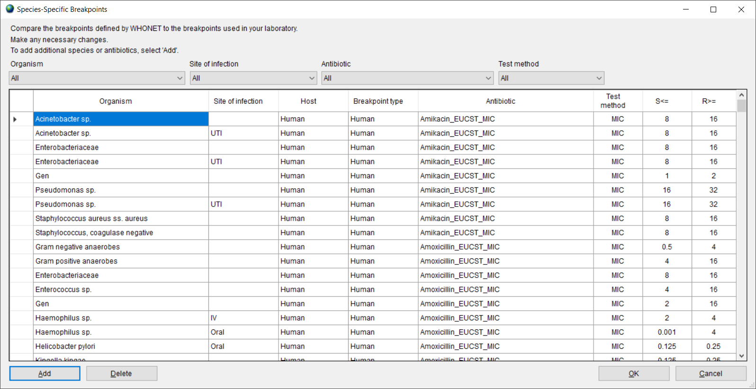

Adding Species-Specific Antibiotic Breakpoints. If you need to enter additional species
-specific breakpoints, select ‘Add’, and the below screen will appear. Indicate the
organism-antibiotic combination for which you want to define breakpoints by clicking on the
desired organism and the desired antibiotic. When finished, select ‘OK’ to return to the
previous screen where you may enter the breakpoints.

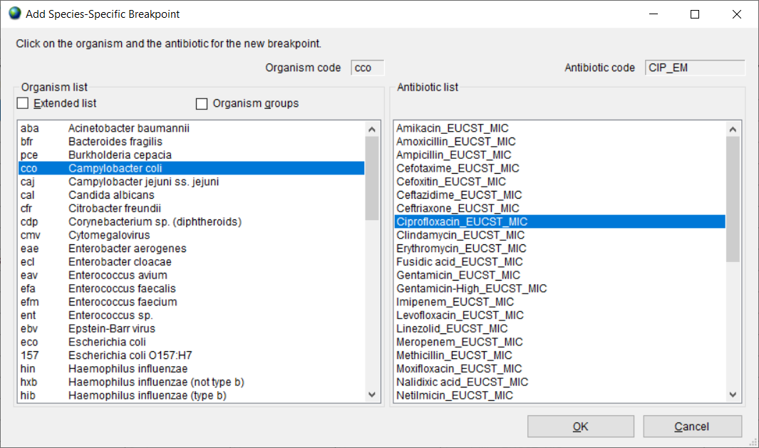

Deleting Species-Specific Antibiotic Breakpoints. To delete a species-specific breakpoint,
click on the relevant row of the table and click ‘Delete’.

After completing your changes to the breakpoints, select ‘OK’ to return to the Antibiotic Breakpoints screen. You may then select ‘OK’ again to return to the ‘Antibiotic Configuration’ screen.

Special instructions for utilizing WHONET 2026 for submission of data utilizing 2025 breakpoints
For countries that submit quantitative susceptibility test results to EARS-Net, specifically zone diameter millimeters or MIC values, then the issue of WHONET breakpoint maintenance is critical for the submission of reliable results.

We can recognize three common situations among EARS-Net countries that utilize WHONET for reporting.

- All laboratories report only R, I, and S interpretations (no test measurements)
If your laboratory network only collects R, I, and S interpretations, but no zone diameter millimetres or MIC values, then the breakpoints utilized by WHONET are not relevant. You can use WHONET 2025 or later versions to prepare your EARS-Net export.

- Laboratories that do report test measurements and plan to utilize WHONET 2025 for data submissions

If your country already has WHONET 2025 and you have already updated your WHONET to use the latest available EUCAST 2025 breakpoints, then you may proceed to prepare your data export through the WHONET interface without changing any other settings.

Alternatively, if you are using WHONET 2025 with older breakpoints, then you should use the ‘Update breakpoints’ feature mentioned above to update to the EUCAST 2025 breakpoints or ensure that you have 2025 selected for the guideline year. Prepare your export after you have updated your breakpoints.

Once you have prepared your 2025 data export in either case above, you may upgrade later to WHONET 2026 if you wish.

- Laboratories that do report test measurements and plan to utilize WHONET 2026 and later versions for data submissions

Starting with WHONET 2026, there is a new feature called “Data year” for selecting the breakpoints to be used for the EARS-Net exports. The screen can be seen in Section 5 of this manual. For example, when submitting results in 2026 for samples collected in 2025, the data manager should choose “2025”. This new feature should simplify the creation of EARS-Net files and decrease the risk that incorrect breakpoints are selected.

This feature allows the user to select the year that corresponds to the year of the sample specifically for the EARS-Net data export. For other WHONET “Data analysis” and “Quick analysis” features, the data manager should continue as in years past selecting the desired antibiotics under “Modify laboratory”, “Antibiotics”, and “Breakpoints”. If you have any questions or difficulties updating your breakpoints or your software, please reach out to the WHONET team at help@whonet.org.

3.6 Locations
This option from the main screen ‘Laboratory Configuration’ is optional but is of value if you would like to keep track of the patient locations and medical services from which samples are taken. A detailed description is found in the main WHONET manual.

3.7 Modifying Data Field Configuration for EARS-Net
A set of ‘standard’ data fields is defined automatically by WHONET. ‘Standard’ fields include such routine information as: patient ID, patient ward, specimen date, specimen type, organism, antibiotic results, etc. Most of these ‘standard’ fields can be removed. To combine other surveillance activities with the EARS-Net data collection, you may want to add some ‘additional’ data fields, see instructions below. If you created your laboratory configuration using ‘EARS-Net / CAESAR’, ‘New laboratory’, then the additional required and optional EARS-Net data fields have already been added to your configuration.

Instructions

Step 1 From the main ‘Laboratory Configuration’ screen, select ‘Data Fields’ and click on ‘Modify list’. You will see a screen similar to the one below. The lists of WHONET data categories (clinical, infection control, etc.) and data fields (diagnosis, admission date, etc.) from which you may select appear to the left. If you select ‘EARS-Net / CAESAR’, this will show the EARS-Net data fields in the box ‘Data fields’. Select them all and click the right arrow. They will be added to the list of data fields that appear to the right (also containing the standard data fields).

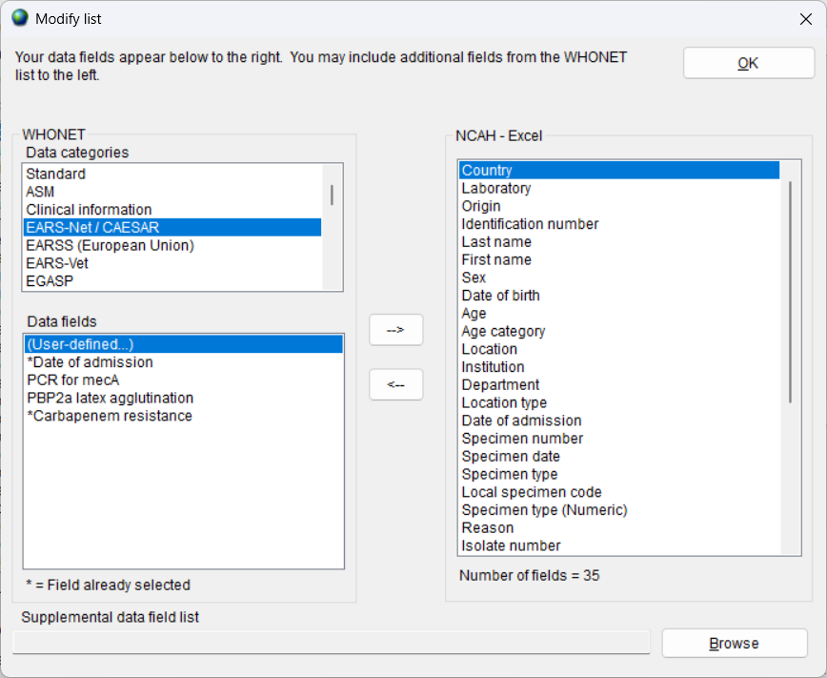

Step 2 If you would like to include more additional fields in your data files, then you may select them here as well.

Note: By default, WHONET will check the validity of EARS-Net codes entered during data entry.

Step 3 Leave this screen, by clicking on ‘OK’ twice and click on ‘Save’ to save this laboratory configuration.

3.8 Copy an existing laboratory configuration

Introduction: if you have created a laboratory configuration for one of the EARS-Net participating laboratories, this option could be useful to create additional copies to be used for the other laboratories in the network.

- Choose from main menu, File, ‘Open laboratory’.
- In case you want to copy an existing laboratory configuration, select the laboratory configuration that you would like to copy, for example from the ‘WHO, EDL’ laboratory, and click on 'Copy laboratory'.

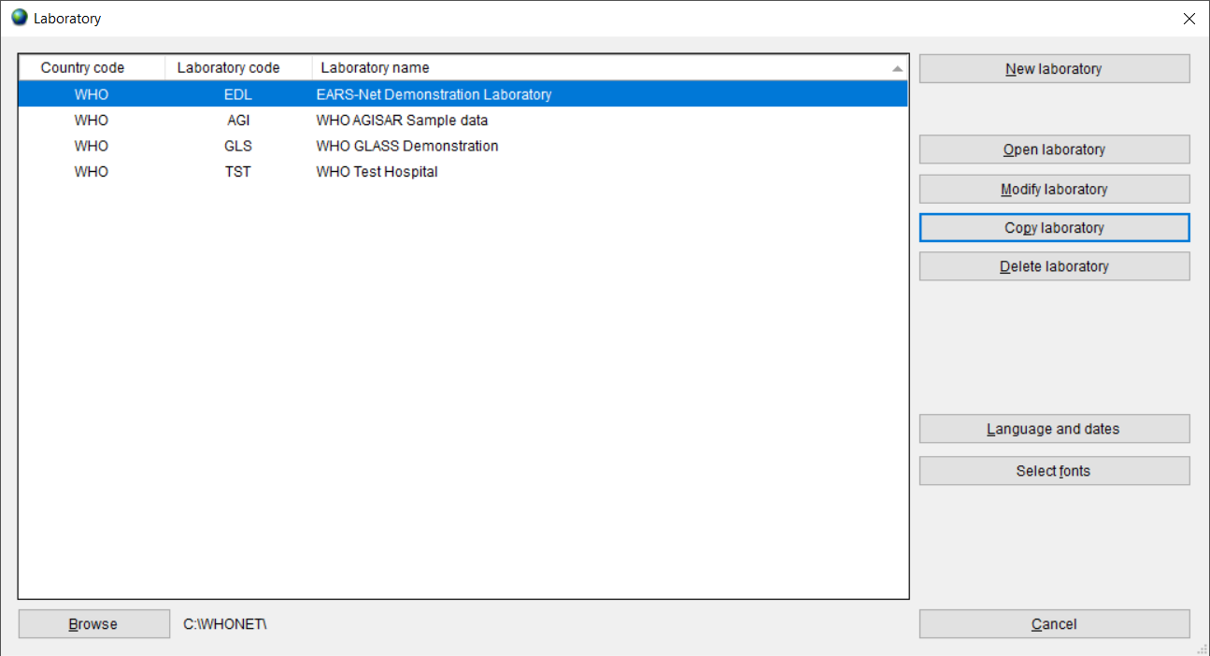

The below screen will appear:

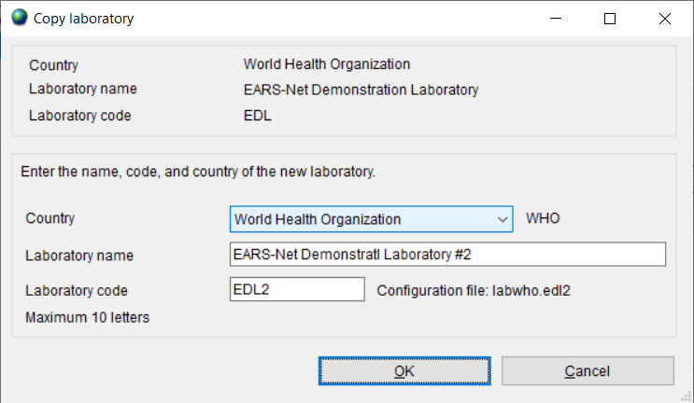

- Enter the country, laboratory name and laboratory code (numbers) and click on 'OK'.

4. WHONET Data entry for EARS-Net

4.1 General
Before you start ‘Data entry’ you must open the corresponding laboratory configuration.

- Click on main menu, File, ‘Open laboratory’. Select lab and click on ‘Open laboratory’.

WHONET uses the data structure defined in the current laboratory configuration and will use the breakpoints as defined in the laboratory configuration.

- You can create a ‘New data file’, or you can ‘Open’ an existing file. When you want to make a new file, click on the ‘Data Entry’ menu and then select ‘New data file’.

The below screen will permit you to give a ‘file name’ and ‘file location’ for your new data file. WHONET automatically suggests the default location of C:\WHONET with the default filename indicating the country, laboratory, and year, e.g. WHO-EDL-2021.sqlite in the below, but you can change this to your preferred file name.

For the past twenty years, WHONET has used data files with the very simple dBASE file structure, and this option remains available. However, the default is now SQLite, which offers many advantages in terms of compatibility, speed, security, file sizes, multiuser support, and number of data columns.

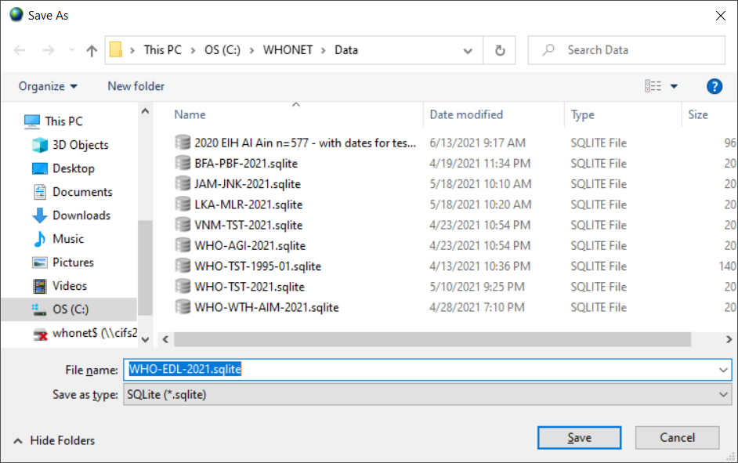

By default, data files are stored in the C:\WHONET\Data folder, but the user may browse to other file locations on the local hard drive or any available network drive.

- Click on ‘OK’ to proceed with data entry.

After you have opened or created a data file, the ‘Data Entry’ screen (below) will appear.
Data are entered in the fields on the left half of the screen. The standard WHONET fields appear first, followed by the antibiotic fields and then the additional EARS-Net data fields that you have selected during laboratory configuration.

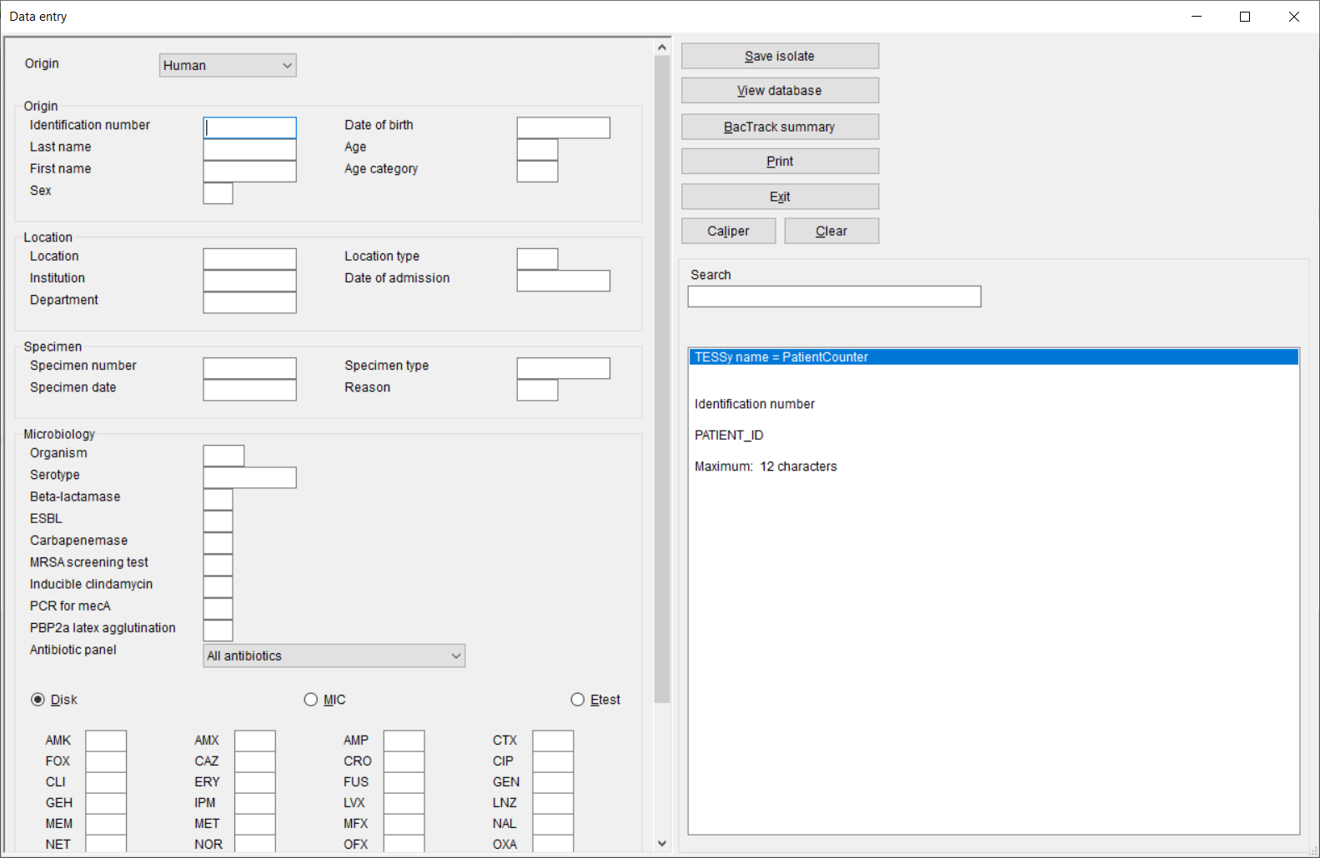

General explanation for data entry:

When the cursor jumps to a field for data entry, brief instructions and recommended data codes for that field appear at the lower right of the screen.

After entering data in one field, you have four ways of moving to the next field:
- press the <Enter> key; or
- press the <Tab> key; or
- press the arrow keys; or
- use the mouse.

Regarding the entry of ‘dates’, the default format is ‘Day-Month-Year’, but this is configurable by the user from the main WHONET menu option ‘File’, ‘Language and dates’ options. When you have entered a date and moved to the next field, check that the date has been interpreted correctly – WHONET automatically converts the numeric date to the name of the month. When entering a date, the year can be entered as a 2- or 4-digit date. The numbers indicating day, month and year must be separated by a ‘/’ or a ‘–‘ or a space.

4.2 Field specific comments:

Patient age
You have the option of entering the patient’s age. However, if you have entered the patient’s date of birth, his/her age will automatically be calculated and inserted in the age field when you enter the specimen date.

Organism codes
The 3-character WHONET organism code should be entered here, or selected from the list on the right half of the screen. By default, only the most common organism codes are listed. To view the extended list, click on the ‘Extended Organism List’ box.

Susceptibility results and the list of antibiotics
To enter susceptibility results, first click on the appropriate test method – disk diffusion, MIC or ETest. The list of antibiotics which you defined for that test method should appear. Each time you enter a result and press <Enter>, the cursor jumps to the next antibiotic in the antibiotic panel for the organism tested. For example, if you are entering results for Staphylococcus aureus (organism code ‘sau’), you will be asked for the Gram-positive drugs only. If you change the panel to ‘All antibiotics’, then you may select from any of the antibiotics in the laboratory’s antibiotic list.

Entering susceptibility results
WHONET allows the entry of quantitative results (e.g. 13 mm, 64 µg/ml) or the entry of qualitative results (R = resistant, I = Susceptible, increased exposure, S = Susceptible, standard dosing regimen).

The lowest possible zone diameter is 6 mm. If you enter 0 mm (indicating no inhibition), WHONET will automatically change this to 6 mm.

For off-scale MIC values you may enter, for example, <=.5, >64.

If you are entering MIC results from the test of a drug combination (e.g. trimethoprim/sulfamethoxazole, piperacillin/tazobactam), enter the result of the first or principal agent. These concentrations usually follow the 1, 2, 4, 8 … doubling-dilution series.

A final completed sample should look similar to the below.

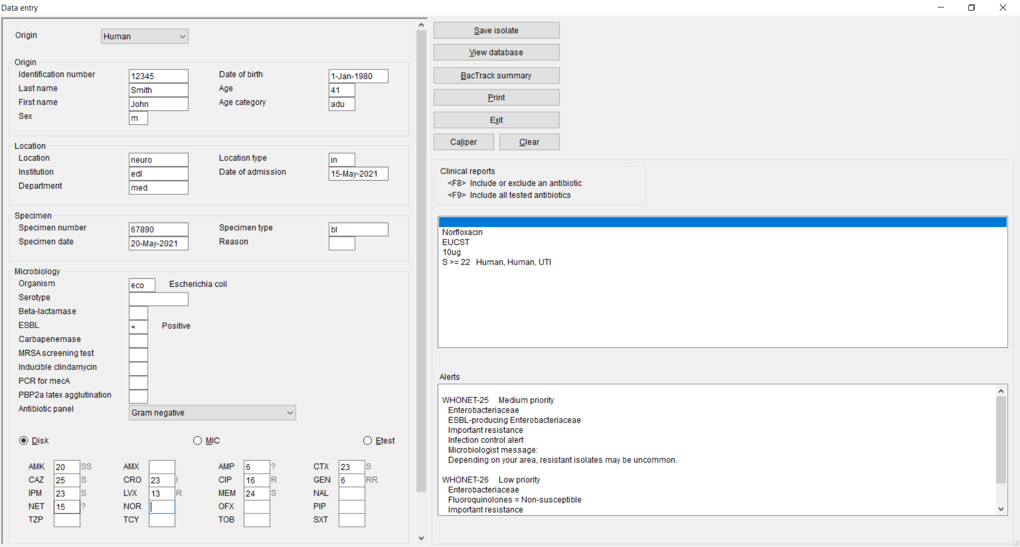

Saving the isolate information
When you have entered all the data for an isolate, click on ‘Save Isolate’ (or press Alt-S). The data will be saved to disk and the ‘Data Entry’ screen will be cleared so that the data for the next isolate can be entered.

WHONET will ask you whether you want to:
Save the isolate
Save and continue with the same isolate
Save and continue with the same patient
click on one of these options to save or on ‘Cancel’, if you decide not to save the record.

Exit data entry
When you have finished entering data, click on ‘Exit’ to return to the main WHONET screen.

4.3 View database

- From menu choose, ‘Data entry’, ‘Open data file’, select data file and click on ‘Open’.
- To check the records after you performed data entry click on ‘View database’, the screen below appears.
- In case you want to make changes, select the record you want to change and ‘Edit isolate’. You will get the data entry screen again, and you can enter the changes. Click on ‘Save Isolate’ to save these changes.

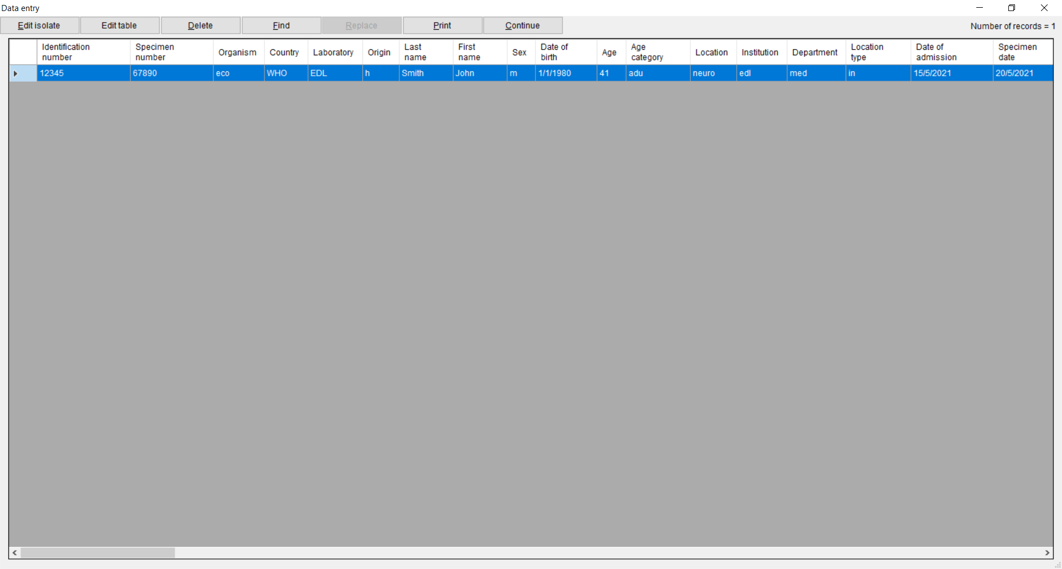

- For leaving this screen above, click on ‘Continue’ and ‘Exit’.

5. Exporting WHONET files to the EARS-Net exchange format

Introduction: after data entry the files are saved in WHONET format. Before uploading them to the EARS-Net data submission platform (EpiPulse Cases), they must be exported to the EARS-Net data exchange format. It is possible that you may have WHONET data from your country stored in a single large WHONET file, or alternatively you may have separate WHONET files representing your various facilities, organisms, and time periods. If you have multiple files, you may wish to combine them together into a single export file using the below procedure to simplify the upload of data to the EARS-Net platform.

Note: Frequently, you may want to combine data files from more than one laboratory into a larger EARS-Net file. If the laboratories test exactly the same antibiotics with the same set of breakpoints, you can combine the data files together using any one of the corresponding laboratory configurations. On the other hand, if the laboratories test different antibiotics or use different breakpoints, you should create a new ‘national’ laboratory configuration which includes a list of all antibiotics tested (with the corresponding breakpoints), as mentioned earlier in Section 3.1.

- From the main WHONET menu, select ‘Data entry’, ‘Combine, export, or encrypt data files’.

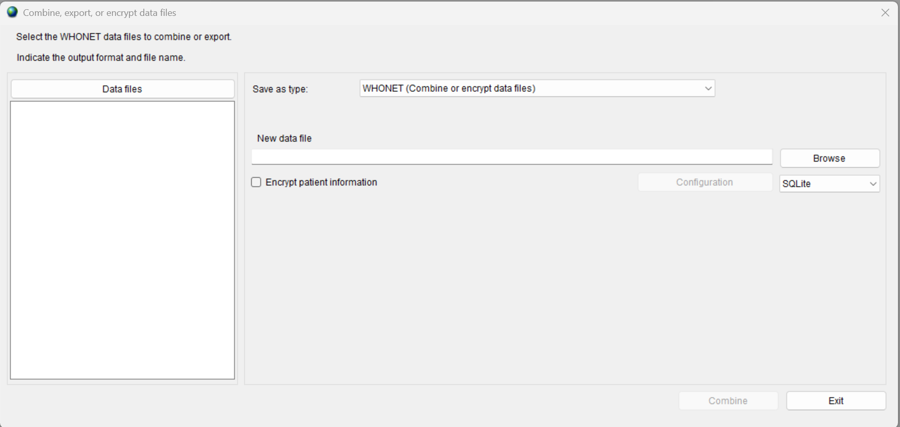

- Click on ‘Data files’.

The next screen will appear. One file has been selected for export, but as many files as the user wishes can be included.

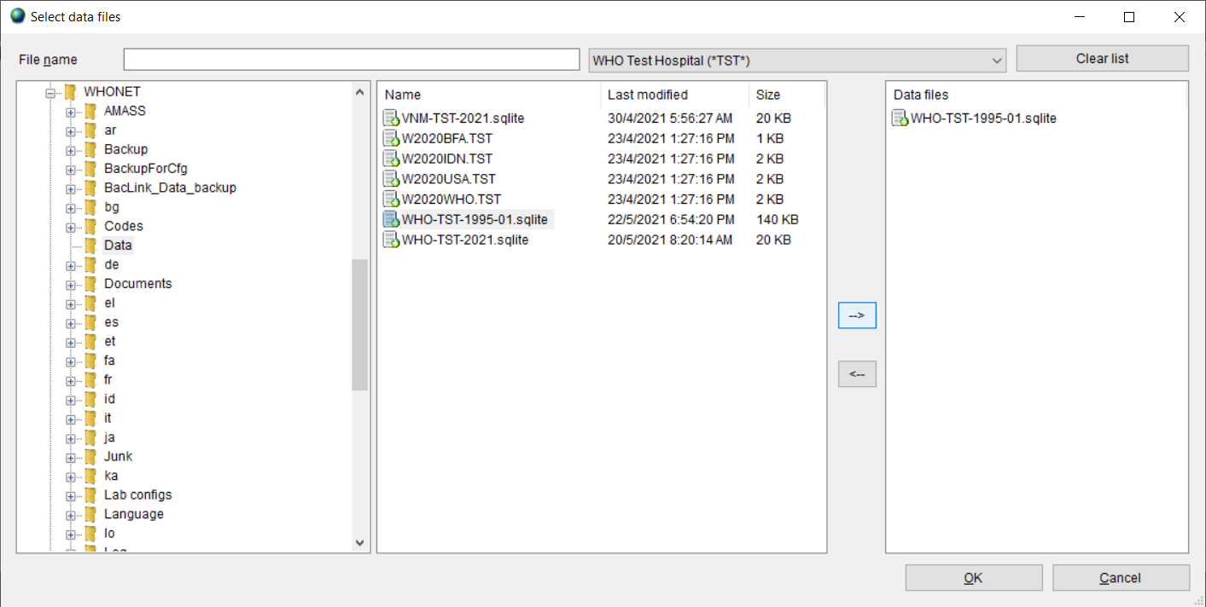

- Choose ‘All files (*.*)’ to get a list.
- Using the ‘-->‘ button, select the data files that you wish to export to the EARS-Net data exchange format.
- Click ‘OK’. You will return to the previous screen.
- Indicate a name for the new combined, export file.
- Under ‘Save as type’, change the export format from ‘WHONET’ to ‘EARS-Net / CAESAR ‘.

In the example below, we combine data from 2015 from several Swedish laboratories into an EARS-Net file named SE2015.CSV. By default, WHONET will save the new file in the C:\whonet5\data folder, though you can change this if desired.

- Ensure that the WHONET proposed ‘Data source’ is correct for your country.

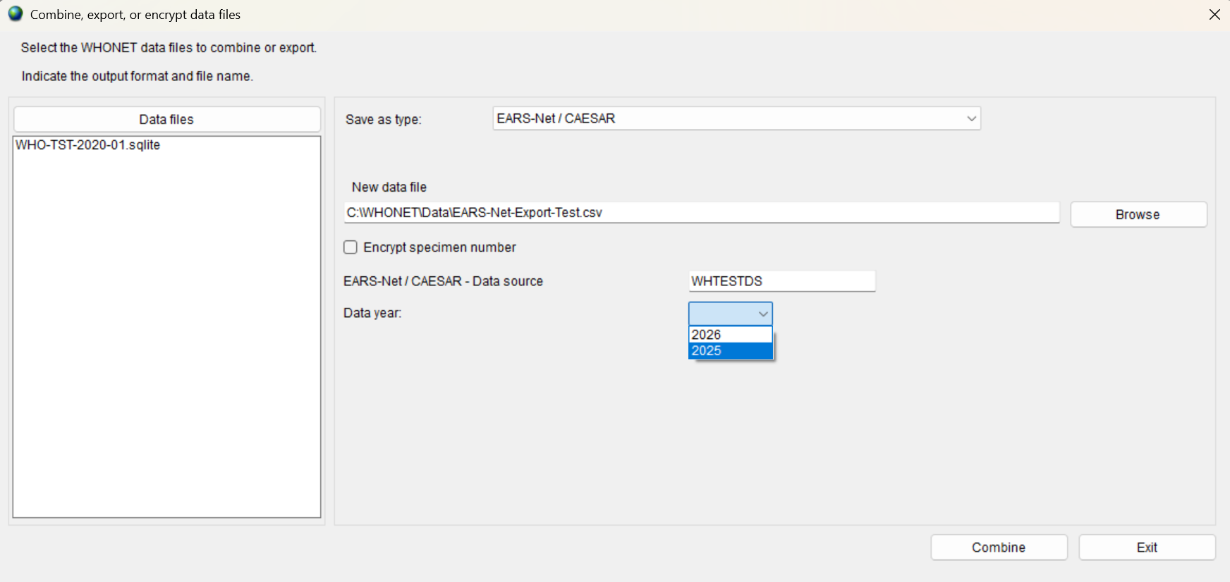

- WHONET 2026 and later: Ensure that the “data year” corresponding to your export has been selected. For example, when exporting results for samples collected in 2025 to be uploaded in 2026, the data manager should select “2025”.
  - Older versions of WHONET do not include the “data year”, and the breakpoints must be set correctly by the user. For this reason, you may wish to upgrade to WHONET 2026 or later to simplify the process and take advantage of this feature.
- Click on ‘Combine’ to begin the export.

WHONET will read the selected data files and export all blood and CSF isolates of S. aureus, E. coli, S. pneumoniae, E. faecalis, E. faecium, P. aeruginosa, K. pneumoniae, and Acinetobacter spp..

- After completion of the data export, WHONET will display a data validation form as shown below. You can use this form to view statistical information about the export and to identify potential issues to correct prior to uploading the data to the EARS-Net platform.
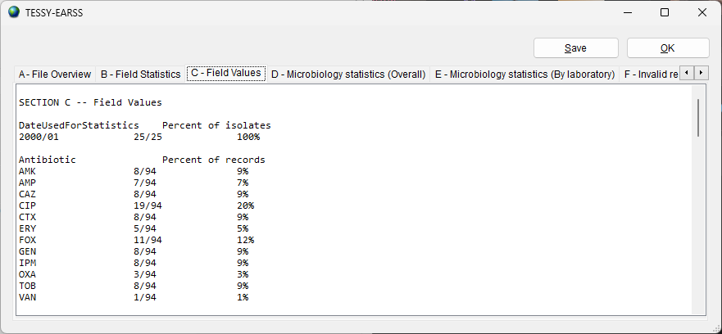

- You may save the text of the validation report to a file by pressing the ‘Save’ button.
- Click on ‘OK’ to close the validation form.
- Press the ‘Exit’ button on the ‘Combine or export’ form.

6. Upload the EARS-Net data file to the EARS-Net data platform - EpiPulse Cases.
Instructions for uploading and reviewing data on the EpiPulse Cases website are provided by EARS-Net and EpiPulse Cases support staff.

The national data manager or national representative assigns laboratory codes to the EARS-Net participant with three characters to identify the laboratory.

